

**North South University**

# Department of Electrical & Computer Engineering

**LAB REPORT**

Course Code: EEE141L

Course Title: Electrical Circuits I Lab

Course Instructor: Dr. Mohammad Abdul Matin (Mtn)

Experiment Number: 6

Experiment Name:

|  |
| --- |
| Verification of Thevenin’s, Norton’s and Maximum Power Transfer Theorem |

Experiment Date: 8/4/2021

Date of Submission: 14/4/2021

Section: 3

Submitted To: Tabia Hossain

|  |  |
| --- | --- |
| Submitted By | Score |
| Student Name and ID:  1. Md. Rifat Ahmed - 1931725042 |  |

**Objectives:**

• Experimentally perform Thevenin’s theorem, Norton’s theorem and Maximum Power theorem

• Perform theoretical calculations.

• Verify the experimental values with theoretical values.

**List of Equipment:**

• OrCAD Software

• PSpice Software

• Resistors (1 × 1kΩ), (1 × 5kΩ), (2 × 10kΩ)

• POT (10kΩ)

• Connecting Wires

**Theory:**

**Thevenin’s Theorem:**

According to Thevenin’s theorem we can simplify any linear circuit, no matter how complex, to an equivalent circuit with just a single voltage source and series resistance connected to a load resistance.

The Thevenin equivalent circuit has one dc voltage source called Thevenin voltage, VTH and a single fixed resistor called Thevenin resistance, RTH.

**Norton’s Theorem:**

According to Norton’s theorem we can simplify any linear circuit, no matter how complex, to an equivalent circuit with just a one current source and parallel resistance connected to a load resistance.

The Norton equivalent circuit has one current source called Norton Current, IN and a single fixed resistor called Norton resistance, RN.

**Usefulness of Thevenin & Norton Theorem:**

In Figure – 1 R2 is a load resistor and if want to find the voltage and current going through it we can apply mesh analysis or nodal analysis or we can use superposition theorem but if the load resistor is not fixed and varies from time to time, we can’t be doing all those calculations again and again that’s where Thevenin and Norton theorem shines. We can simplify a circuit to Thevenin or Norton equivalence circuit and then just calculate everything according to the change of load resistor.

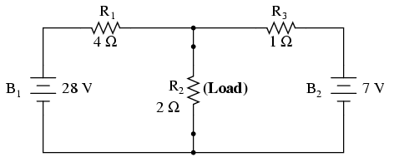

Figure – 1

**Calculating the Thevenin voltage:**

We first remove the load resistance from the circuit then calculate the open-circuit voltage at the terminals of the load resistance to calculate the Thevenin voltage of the circuit.

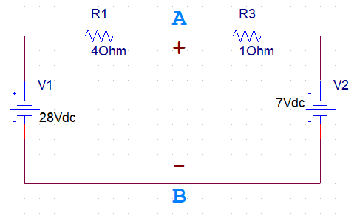

**Calculating the Thevenin/Norton Resistance:**

After removing the load resistance, we short the circuit for all the independent voltage sources and calculate the resistance at the terminals of the load resistor to get out Thevenin resistance.

And Norton resistance needs to be calculated the same way as Thevenin resistance so they’re equal.

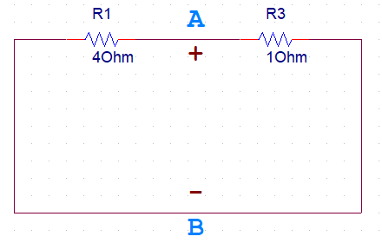

**Thevenin Norton Equivalence:**

Both Thevenin and Norton equivalent circuits are intended to behave the same as the original network supplying voltage and current to the load resistor. In other words, both Thevenin and Norton equivalent circuits should produce the same voltage across the load terminals with no load attached.

Thevenin and Norton resistance both needs to be calculated the same way and are equal. So,

RThevenin = RNorton

VThevenin = INorton RThevenin

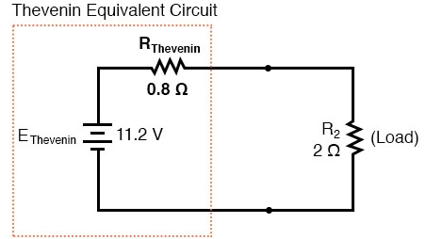

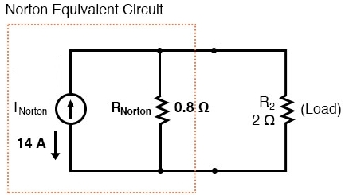

**Calculating the Norton Current:**

Thevenin and Norton are both equivalent circuits so to calculate Norton current, IN we can use VTH,

INorton = VThevenin / RNorton

=> INorton = VThevenin / RThevenin

**Maximum Power Theorem:**

Maximum power theorem states that maximum power will be delivered to the load when that load resistance is equal to the Thevenin/Norton resistance of the network supplying the power. If the load resistance is lower or higher than the Thevenin or Norton resistance then the power dissipated will be less than maximum.

In a Thevenin or Norton Equivalent circuit,

IL = VTH / (RTH + RL)

For maximum power RL = RTH,

IL = VTH / (RTH + RTH) = VTH / 2RTH

**؞** PMax = IL2 RL = VTH2 / 4RTH

**Circuit Diagram:**

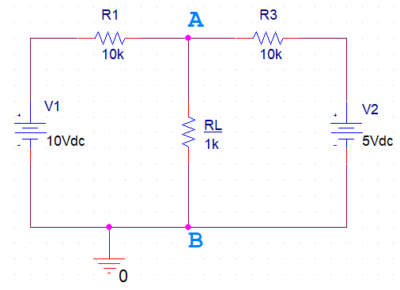

**Circuit – 1**

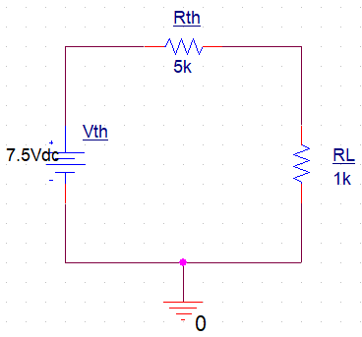

**Circuit – 2**

**Data, Readings and Results:**

**Table 2:**

|  |  |  |  |
| --- | --- | --- | --- |
| **Value** | **Measured** | **Calculated** | **% Error** |
| **VL** | 1.25 V | 1.25 V | 0% |
| **IL** | 1.25 mA | 1.25 mA | 0% |

**Table 3:**

|  |  |  |  |
| --- | --- | --- | --- |
| **Value** | **Measured** | **Calculated** | **% Error** |
| **VTH** | 7.5 V | 7.5 V | 0% |
| **IN** | 1.5 mA | 1.5 mA | 0% |
| **RTH** | 5 kΩ | 5 kΩ | 0% |
| **VL** | 1.25 V | 1.25 V | 0% |
| **IL** | 1.25 mA | 1.25 mA | 0% |

**Table 4:**

|  |  |
| --- | --- |
| **Thevenin’s Equivalent Circuit** | **Norton’s Equivalent Circuit** |
|  |  |

**Table 5:**

|  |  |  |  |  |
| --- | --- | --- | --- | --- |
| **RL (kΩ)** | **VL (Experimental)** | **PL (Experimental)** | **PL (Calculated)** | **% Error of PL** |
| **1** | 1.250 V | 1.563 mW | 1.563 mW | 0% |
| **2** | 2.143 V | 2.296 mW | 2.296 mW | 0% |
| **3** | 2.813 V | 2.637 mW | 2.638 mW | 0.04% |
| **4** | 3.333 V | 2.778 mW | 2.777 mW | 0.04% |
| **5** | 3.750 V | 2.813 mW | 2.813 mW | 0% |
| **6** | 4.091 V | 2.789 mW | 2.789 mW | 0% |
| **7** | 4.375 V | 2.734 mW | 2.734 mW | 0% |
| **8** | 4.615 V | 2.663 mW | 2.662 mW | 0.04% |
| **9** | 4.821 V | 2.583 mW | 2.582 mW | 0.04% |
| **10** | 5.000 V | 2.500 mW | 2.500 mW | 0% |

**Percentage Error Calculation (For Table 5):**

We’ve calculated all the values of PL for different loads in Question no 7.

Now, to calculate the percentage error, we know,

Formula to calculate % Error = X 100%

% Error of PL for 1kΩ load = || × 100% = 0%

% Error of PL for 2kΩ load = || × 100% = 0%

% Error of PL for 3kΩ load = || × 100% = 0.04%

% Error of PL for 4kΩ load = || × 100% = 0.04%

% Error of PL for 5kΩ load = || × 100% = 0%

% Error of PL for 6kΩ load = || × 100% = 0%

% Error of PL for 7kΩ load = || × 100% = 0%

% Error of PL for 8kΩ load = || × 100% = 0.04%

% Error of PL for 9kΩ load = || × 100% = 0.04%

% Error of PL for 10kΩ load = || × 100% = 0%

**Graphical Analysis:**

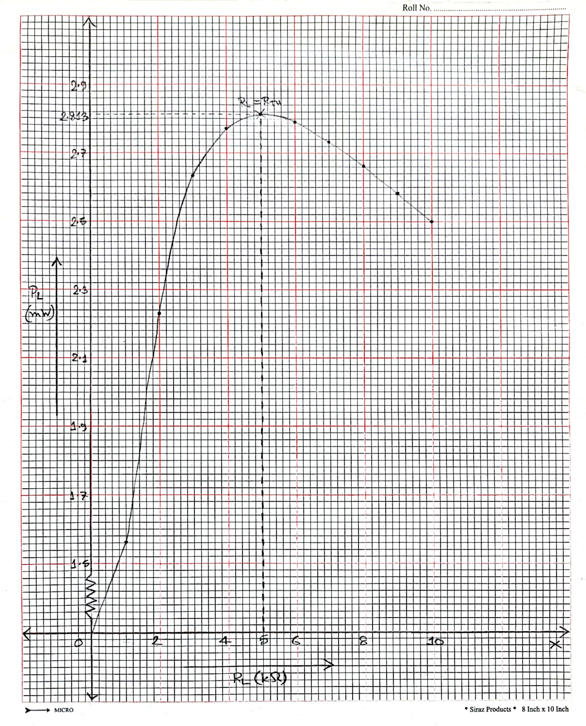

Fig: PL vs RL Graph

The PL vs RL graph above is drawn using the data from Table 5. In this graph as we increased the load the value of PL was also increasing until it reached the peak where we got the maximum power and at that point RL was 5kΩ. So, the peak point was for 5kΩ load where we got PL = 2.813 mW. And then the power started to decline as we increased the load.

So according to the power theorem we’ll get the maximum power when RL is equal to RTH and in this graph we can clearly see that happening as the power was increasing at first and reached the maximum point where RL = 5kΩ = RTH and then PL started to decrease so we can say that the graph satisfies the maximum power theorem.

**Questions and Answers:**

**Answer of Question 1:**

Calculating the theoretical values for Table 2,

Applying nodal analysis at Node A of circuit – 1 to get VL ,

(VL – 10)/10 + VL/1 + (VL – 5)/10 = 0

=> (VL/10) – 1 + VL + (VL/10) – 0.5 = 0

=> VL/10 + VL + VL/10 = 1.5

=> = 1.5

=> 12VL = 15

؞ VL = 1.25 V

Now, IL = VL / RL

=> IL = 1.25V / 1kΩ

؞ IL = 1.25 mA

% Error for IL = X 100%

= X 100%

= 0%

& % Error for VL = X 100%

= X 100%

= 0%

**Answer of Question 2:**

Calculating the theoretical values for Table 3 using Thevenin’s and Norton’s theorem,

Removing the Load Resistor and applying nodal analysis at Node A to get VTH ,

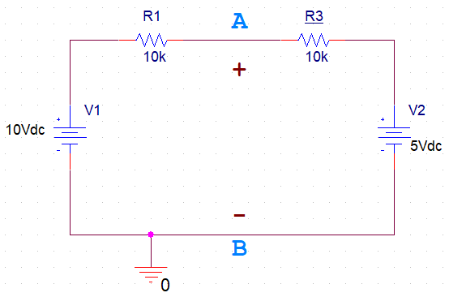

(VTH – 10)/10 + (VTH – 5)/10 = 0

=> (VTH/10) – 1 + (VTH/10) – 0.5 = 0

=> VTH/5 = 1.5

؞ VTH = 7.5 V

Now, the two 10kΩ resistors are in parallel,

؞ RTH = = 5kΩ

So, IN = VTH / RTH

=> IN = 7.5V / 5kΩ

؞ IN = 1.5 mA

IL = VTH / (RL + RTH)

=> IL = 7.5V / (1+5)kΩ

؞ IL = 1.25 mA

VL = IL RL

=> VL = 1.25mA × 1kΩ

؞ VL = 1.25 V

Formula to calculate % error is = X 100%

؞ % Error for VTH = X 100% = 0%

% Error for IN = X 100% = 0%

% Error for RTH = X 100% = 0%

% Error for IL = X 100% = 0%

& % Error for VL = X 100% = 0%

Here, we can see that the percentage error for all VTH, RTH, IN­, IL, VL is zero. Which means that the experimental values of all these are exactly the same as the theoretical values that we calculated using Thevenin’s and Norton’s theorem which indicates that the Thevenin’s and Norton’s theorem stands for our experimental values. So, Thevenin’s and Norton’s theorem is verified.

**Answer of Question 3:**

We know that both Thevenin and Norton circuit produces the same result. And the equivalence relation between these two theorems can be denoted as,

RN = RTH

=> VTH = IN RN = IN RTH

So, the voltage drop at the load resistor for both theorems should be same if the circuits are equivalent as they’re always going to produce the same result for different values of the load resistor.

Now, if we take a look at table 3, we can see that the load resistor has a voltage drop of 1.25 V for the Thevenin circuit so if both the theorem are equivalent then for Norton equivalent circuit the voltage drop at the load resistor should be same.

VL = IL RL = × IN × RL

=> VL = × 1.5 × 1

؞ VL = 1.25 V

The value of the voltage drop at the load resistor is same for both the circuit so, this proves that the Thevenin and Norton are equivalent circuit. (Proved)

**Answer of Question 4:**

The Graph is Drawn in the Graphical Analysis section above.

**Answer of Question 5:**

From the graph we can see that for RL = 5kΩ we get the maximum power.

**Answer of Question 6:**

From Question no 3 we get,

VTH = 7.5 V

RTH = 5kΩ

Maximum Power,

PMax = VTH2 / 4 RTH

=> PMax = (7.5V)2 / (4 × 5kΩ)

؞ PMax = 2.813 mW

**Answer of Question 7:**

Verifying the maximum power theorem:

According to the maximum power theorem, maximum power will be delivered to the load when that load resistance is equal to the Thevenin/Norton resistance of the network supplying the power. So, when RL = RTH we’ll get the maximum power PMax. So, the maximum power theorem will be verified if the power we get for higher or lower load is less than what we get when RL = RTH.

From Q3 we get, RTH = 5kΩ so power should be max for RL = 5kΩ.

Now, P for 1kΩ load,

VL = × 7.5

؞ VL = 1.250 V

P = VL2 / RL = (1.250)2 / 1kΩ

؞ P = 1.563 mW

Now, P for 2kΩ load,

VL = × 7.5

؞ VL = 2.143 V

P = VL2 / RL = (2.143)2 / 2kΩ

؞ P = 2.296 mW

Now, P for 3kΩ load,

VL = × 7.5

؞ VL = 2.813 V

P = VL2 / RL = (2.813)2 / 3kΩ

؞ P = 2.638 mW

P for 4kΩ load,

VL = × 7.5

؞ VL = 3.333 V

P = VL2 / RL = (3.333V)2 / 4kΩ

؞ P = 2.777 mW

Now, P for 5kΩ load,

VL = × 7.5

؞ VL = 3.750 V

P = VL2 / RL = (3.750)2 / 5kΩ

؞ P = 2.813 mW

Now, P for 6kΩ load,

VL = × 7.5

؞ VL = 4.091 V

P = VL2 / RL = (4.091 V)2 / 6kΩ

؞ P = 2.789 mW

Now, P for 7kΩ load,

VL = × 7.5

؞ VL = 4.375 V

P = VL2 / RL = (4.375)2 / 7kΩ

؞ P = 2.734 mW

Now, P for 8kΩ load,

VL = × 7.5

؞ VL = 4.615 V

P = VL2 / RL = (4.615)2 / 8kΩ

؞ P = 2.662 mW

Now, P for 9kΩ load,

VL = × 7.5

؞ VL = 4.821 V

P = VL2 / RL = (4.821)2 / 9kΩ

؞ P = 2.582 mW

Now, P for 10kΩ load,

VL = × 7.5

؞ VL = 5.000 V

P = VL2 / RL = (5.000)2 / 10kΩ

؞ P = 2.500 mW

Here, we can see that the values of P starts to increase as we increase the load but when it equals to the Thevenin resistance, RTHwe get the maximum value of P (PMax) and then the value of P starts to fall.

So, we get the maximum power when the load is equal to the Thevenin resistance which is what the maximum power theorem says.

؞ Maximum Power theorem is verified.

**Discussion:**

From this experiment we’ve learned three new theorems – Thevenin’s, Norton’s and Maximum Power theorem. We can use Thevenin or Norton’s theorem to simplify any linear circuit to an equivalent circuit that has only one voltage source in case of Thevenin’s and only one current source in case of Norton’s and one single fixed resistor and a load resistor connected in series for Thevenin’s and in parallel for Norton’s theorem. This is a great way to simplify a complex circuit. And finally, from the maximum power theorem we learned how to calculate the maximum power a circuit can reach. As for the result of our experiment, the percentage of error we got was very low, zero for some and close to zero for some, meaning that our experiment was done correctly. However, during this experiment it got a bit confusing working with three new theorems at the same time so had to go through the manual and recording a few times to clear things other than that everything was good.